CHEM 1021 — Exam 3 Practice Test
Day 6 of 7
Date: ______________________ Score: ________ / 100
Instructions: 25 multiple-choice questions, 4 points each. Choose the single best answer. Give yourself 50 minutes. Use only the reference information below, a periodic table, and a calculator. Fill in the answer sheet on the last page, then grade with the Day 6 Answer Key.
Reference Information
Equations and constants: Molarity = moles solute ÷ liters of solution · M₁V₁ = M₂V₂ · Nₐ = 6.022 × 10²³ · 1 cm³ = 1 mL · 1 L = 1 dm³ · 0.3047 m = 1 ft
The 7 strong acids: HCl, HBr, HI, H₂SO₄, HNO₃, HClO₄, HClO₃. Strong bases: all soluble hydroxide salts.
Common polyatomic ions: ammonium NH₄⁺ · hydronium H₃O⁺ · hydroxide OH⁻ · cyanide CN⁻ · carbonate CO₃²⁻ · phosphate PO₄³⁻ · chlorate ClO₃⁻ · bromate BrO₃⁻ · iodate IO₃⁻ · sulfate SO₄²⁻ · selenate SeO₄²⁻ · nitrate NO₃⁻ · acetate CH₃CO₂⁻
Acid naming: no oxygen → hydro- + root + -ic acid · -ate ion → -ic acid · -ite ion (one fewer O) → -ous acid · one more O than the -ate → per- + root + -ic acid · one fewer O than the -ite → hypo- + root + -ous acid
Activity Series (most → least active; a metal displaces any metal ion listed below it)
Group | Metals | Reacts with
1 | K, Ba, Sr, Ca, Na | Cold water, steam, and acids (produce H₂)
2 | Mg, Al, Mn, Zn, Cr, Fe, Cd | Steam and acids (produce H₂)
3 | Co, Ni, Sn, Pb | Acids only (produce H₂)
— | H₂ | —
4 | Sb, Bi, Cu, Ag, Hg, Pd, Pt | Do not react with water, steam, or acids
Electronegativity (main-group values)
Period | 1 | 2 | 13 | 14 | 15 | 16 | 17
1 | H 2.1
2 | Li 1.0 | Be 1.5 | B 2.0 | C 2.5 | N 3.0 | O 3.5 | F 4.0
3 | Na 0.9 | Mg 1.2 | Al 1.5 | Si 1.8 | P 2.1 | S 2.5 | Cl 3.0
4 | K 0.8 | Ca 1.0 | Ga 1.6 | Ge 1.8 | As 2.0 | Se 2.4 | Br 2.8
5 | Rb 0.8 | Sr 1.0 | In 1.7 | Sn 1.8 | Sb 1.9 | Te 2.1 | I 2.5
Solubility Rules
Ion | Rule | Exceptions
Na⁺, K⁺, NH₄⁺ | Salts with an alkali metal or ammonium ion are soluble | None
NO₃⁻, CH₃CO₂⁻ | All nitrates and acetates are soluble | None
SO₄²⁻ | Most sulfates are soluble | BaSO₄, SrSO₄, PbSO₄, CaSO₄, Hg₂SO₄, Ag₂SO₄
Cl⁻, Br⁻, I⁻ | Most chlorides, bromides, and iodides are soluble | AgX, Hg₂X₂, PbX₂, HgI₂
Ag⁺ | Silver compounds are generally insoluble | AgNO₃ and AgClO₄ are soluble; AgCH₃CO₂ is slightly soluble
O²⁻, OH⁻ | Oxides and hydroxides are insoluble | Alkali metal hydroxides, Ba(OH)₂, Sr(OH)₂; Ca(OH)₂ is somewhat soluble
S²⁻ | Sulfides are insoluble | Compounds with Na⁺, K⁺, NH₄⁺, and alkaline earth cations
CrO₄²⁻ | Most chromates are insoluble | Compounds with Na⁺, K⁺, NH₄⁺, Mg²⁺, Ca²⁺, Al³⁺, Ni²⁺
CO₃²⁻, PO₄³⁻, SO₃²⁻, SiO₃²⁻ | Most carbonates, phosphates, sulfites, and silicates are insoluble | Compounds with Na⁺, K⁺, NH₄⁺

1. Returning Topic: Report the answer to the following calculation with the correct number of significant figures:
(0.004050 × 12.0) ÷ 3.7
A. 0.01
B. 0.013
C. 0.0131
D. 0.01314
2. Returning Topic: How many square feet are there in 10.0 square meters? (0.3047 m = 1 ft)
A. 0.929 ft²
B. 3.05 ft²
C. 32.8 ft²
D. 108 ft²
3. Returning Topic: Consider the transition metal cobalt (Z = 27). How many d electrons are in the ground-state electron configuration of the Co³⁺ ion?
A. 4
B. 6
C. 7
D. 9
4. Returning Topic: Which of the following is the correct electron configuration for a neutral manganese (Z = 25) atom?
A. [Ar]4s¹3d⁶
B. [Ar]3d⁷
C. [Ar]4s²4d⁵
D. [Ar]4s²3d⁵
5. Vanadium forms the following compound with oxygen: V₂O₅. What is the name of this compound?
A. vanadium oxide
B. vanadium(V) oxide
C. divanadium pentoxide
D. vanadium(II) oxide
6. Which of the following anions would form the strongest bond with a sodium ion, Na⁺?
A. F⁻
B. Cl⁻
C. O²⁻
D. Se²⁻
7. Consider the compound Cl₂O₇. What is the correct name for this compound?
A. chlorine(VII) oxide
B. dichlorine heptoxide
C. dichlorine hexoxide
D. chlorine oxide
8. The element trivexium reacts with folane to form a compound with the name trivexium difolide. Which of the following statements about this compound is correct?
A. The compound has one trivexium atom for every two folane atoms.
B. Trivexium is a metal.
C. Folane is further left or below trivexium on the periodic table.
D. The compound contains three trivexium atoms.
9. Categorize the following compounds as ionic or covalent.
I: SF₆ II: BaCl₂ III: NO₂
A. I, II, and III are all covalent.
B. I and III are ionic; II is covalent.
C. I and II are ionic; III is covalent.
D. II is ionic; I and III are covalent.
10. Which of the following bonds is most polar? (Use the electronegativity table.)
A. S–H
B. Cl–H
C. P–H
D. O–H
11. What is the electron domain geometry on the atom X in the structure shown?
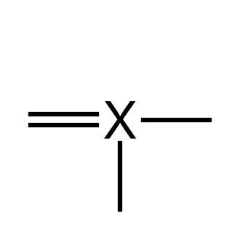
A. Trigonal planar
B. Tetrahedral
C. Trigonal pyramidal
D. Linear
12. Predict the molecular shape and the approximate bond angle of formaldehyde, CH₂O (C is the central atom).
A. Bent, < 109.5°
B. Trigonal pyramidal, < 109.5°
C. Tetrahedral, 109.5°
D. Trigonal planar, 120°
13. Nitric acid, HNO₃, exhibits resonance. The first resonance structure is shown. Which structure is another valid resonance structure for nitric acid?
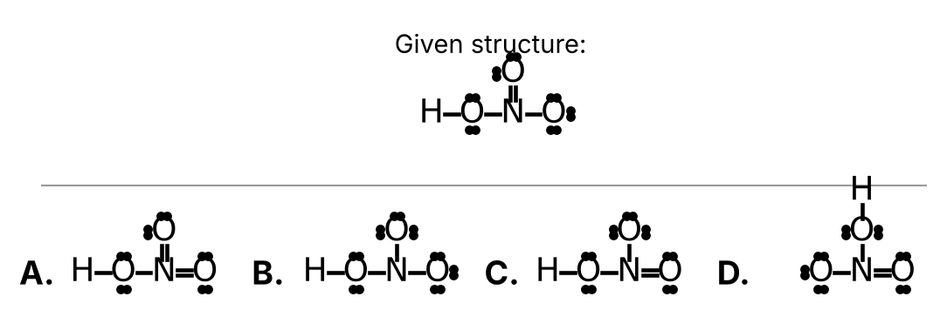
Choose A, B, C, or D from the figure.
14. A solution is made by dissolving a small amount of water in a large amount of ethanol. Which of the following statements about this solution is correct?
A. Water is always the solvent.
B. There is no solute because both are liquids.
C. The solvent is ethanol and the solute is water.
D. The solvent is water and the solute is ethanol.
15. How many moles of glucose are contained in 75.0 mL of a 2.20 M glucose solution?
A. 0.0341 mol
B. 0.165 mol
C. 29.4 mol
D. 165 mol
16. Use the solubility rules to determine which of the following compounds is soluble in water.
A. CuS
B. Al(NO₃)₃
C. Ni(OH)₂
D. SrSO₄
17. Brennite (Bn) is a fictional non-metal that forms an acid with the formula H₂Bn. What is the name of this compound?
A. Hydrobrennic acid
B. Brennic acid
C. Hypobrennous acid
D. Hydrobrennous acid
18. Fennium (Fn) is a fictional element that forms the polyatomic ion named fennite with the formula FnO₃³⁻. What would be the name of the acid with the chemical formula H₃FnO₂?
A. Perfennic acid
B. Fennic acid
C. Hypofennous acid
D. Fennous acid
19. Which of the following soluble compounds when dissolved in water will not create an electrolyte solution?
A. HI
B. LiOH
C. K₂SO₄
D. CO(NH₂)₂ (urea)
20. Consider the following chemical reaction:
C₃H₈ (g) + 5 O₂ (g) → 3 CO₂ (g) + 4 H₂O (g)
Which of the following statements about this reaction is incorrect?
A. CO₂ and H₂O are products.
B. 1 molecule of propane reacts with 5 molecules of oxygen.
C. 1 gram of propane reacts with exactly 5 grams of oxygen.
D. All species are in the gas phase.
21. Balance the following chemical equation:
NH₃ (g) + O₂ (g) → NO (g) + H₂O (g) (unbalanced)
How many atoms of hydrogen are found on the product side when the equation is properly balanced?
A. 3
B. 4
C. 6
D. 12
22. Dichlorine heptoxide reacts with water to produce perchloric acid. Write a properly balanced chemical equation for this reaction. How many perchloric acid molecules are produced?
A. 1
B. 2
C. 4
D. 7
23. Consider the following chemical reaction:
Cl₂ + 2 KBr → 2 KCl + Br₂
This reaction would be classified as a ____.
A. Single Displacement Reaction
B. Double Displacement Reaction
C. Synthesis (Combination) Reaction
D. Decomposition Reaction
24. Which of the following chemical reactions will occur?
A. Cu (s) + FeSO₄ (aq) → CuSO₄ (aq) + Fe (s)
B. Ni (s) + 2 H₂O (ℓ) → Ni(OH)₂ (aq) + H₂ (g)
C. 2 Bi (s) + 6 HCl (aq) → 2 BiCl₃ (aq) + 3 H₂ (g)
D. Ba (s) + 2 H₂O (ℓ) → Ba(OH)₂ (aq) + H₂ (g)
25. Glucose, C₆H₁₂O₆, burns completely in oxygen. What are the products?
A. CO₂ and H₂O
B. CO₂, H₂O, and O₂
C. CO and H₂
D. C and H₂O

Answer Sheet — Day 6
Circle one letter per question.
# | Answer | # | Answer | # | Answer
1 | A B C D | 10 | A B C D | 19 | A B C D
2 | A B C D | 11 | A B C D | 20 | A B C D
3 | A B C D | 12 | A B C D | 21 | A B C D
4 | A B C D | 13 | A B C D | 22 | A B C D
5 | A B C D | 14 | A B C D | 23 | A B C D
6 | A B C D | 15 | A B C D | 24 | A B C D
7 | A B C D | 16 | A B C D | 25 | A B C D
8 | A B C D | 17 | A B C D
9 | A B C D | 18 | A B C D

